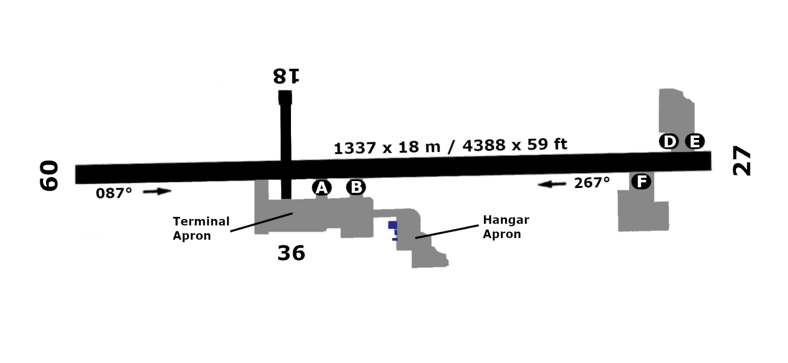

336 m
336 m
51°41”10’S
68 ft
68 ft
SFAL – PORT STANLEY
36
18
27
09
1.0
1337 m
1337 m
57°46”05’W
1.0

